|  |
| --- |
| PS2Win |
| Weekly Report |
| Keep Your Time |

|  |
| --- |
| Carla Machado;Filipe Brandão  07-04-2013 |

**Team Members:**

Carla Machado

David João

Filipe Brandão

João Girão

João Martins

Mário Oliveira

Rui Ganhoto

**Week 7**, 1th of April to 8th of April

Content

1. Week Activities 1

1.1. Work Executed 1

1.2. Work Analyses 1

1.3. Achievements 1

2. Impediments 1

3. Plans For Next Week 2

4. Progress 2

4.1. Earned value and/or Gantt Image 2

4.2. Effort by task 3

4.3. Individual effort 3

5. Individual log 4

**Images**

Figure 1: Earned Value 2

Figure 2: Week effort by task type 3

Figure 3: Week effort by team member 3

**Tables**

Table 1: List of Contributors ii

Table 2: Version history ii

Table 3: Log of individual effort 4

|  |  |  |  |
| --- | --- | --- | --- |
| **Authors and Contributors** | | | |
| **Date** | **Name** | **Contacts** | **Contribution** |
| 07-04-2013 | Carla Machado | a21170460@alunos.isec.pt | Author |
| 08-04-2013 | Filipe Brandão | a21180276@alunos.isec.pt | Author |
| 08-04-2013 | Mário Oliveira | a21170292@alunos.isec.pt | Contributor |
| 08-04-2013 | Rui Ganhoto | a21170262@alunos.isec.pt | Contributor |
|  |  |  |  |
|  |  |  |  |

Table 1: List of Contributors

|  |  |  |  |  |  |
| --- | --- | --- | --- | --- | --- |
| **Revision History** | | | | | |
| **Date** | **Description** | **Author** | **Version** | **Approvers** | **State** |
| 07-04-2013 | Creation of first draft | Carla Machado | 0.1 |  | Draft |
| 08-04-2013 | Added graphs, updated work executed and individual tasks | Filipe Brandão | 0.2 |  | Draft |
| 08-04-2013 | Small corrections. | Carla Machado | 0.3 |  | Ready for Revision |
| 08-04-2013 | Document reviewed | Mário Oliveira | 0.3 |  | Ready for Revision |
| 08-04-2013 | Small changes due to the revision | Carla Machado | 0.4 |  | Ready for Revision |
| 08-04-2013 | Changing State | Filipe Brandão | 0.4 |  | Ready for Approval |
| 08-04-2013 | Approval |  | 0.4 | João Martins |  |
| 08-04-2013 | Approval |  | 0.4 | Rui Ganhoto |  |
|  |  |  |  |  |  |
|  |  |  |  |  |  |
|  |  |  |  |  |  |
|  |  |  |  |  |  |

Table 2: Version history

# Week Activities

# Work Executed

* Approval of the Project Planning Process
* Estimation of the foreseen tasks for the project
* Quality plan is ready for revision
* Project Plan is ready for revision
* Verification and Validation process is ready for approval
* Project Assessment and Control is ready for revision
* Coding Standards document is ready for revision
* Preparation of the Kick of Meeting (KOM)

# Work Analyses

This week’s work was manly related do the preparation of the KOM and assuring that all the required documents were prepared such as the project plan and the quality plan.

The effort involved in the estimation meeting and the necessity of having the project plan and quality plan ready for the KOM combined with the difficulties in reaching a viable scheduling and the fact that these tasks were performed in the same work week were the main reasons behind the overwork performed this week.

The difficulties in scheduling all the tasks initially foreseen for the application in a single release combined with the fact that the dependency between them was dragging the project beyond the time limit. A decision was made to organize the application in various releases and make the scheduling only for the first release.

# Achievements

* Project Planning Process is baselined
* Project Assessment and Control Process is ready for revision
* Quality Plan and Project Plan ready for the KOM
* Coding Standards ready for revision
* Verification and Validation Process is ready for approval

# Impediments

* The planning of the project brought some difficulties namely in the scheduling of the various tasks
  + Dependency between tasks prevented the scheduling of all the tasks within the time limit

# Plans For Next Week

* Start the Requirements Analysis
* Finishing the remaining processes
* Prepare Earned Value

# Progress

# Earned value and/or Gantt Image

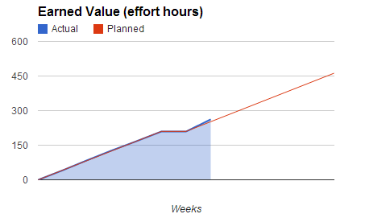

Figure 1: Earned Value

Actual = 262h

Planned = 252h

# Effort by task

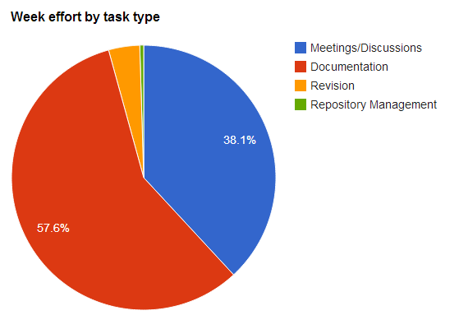

Figure 2: Week effort by task type

# Individual effort

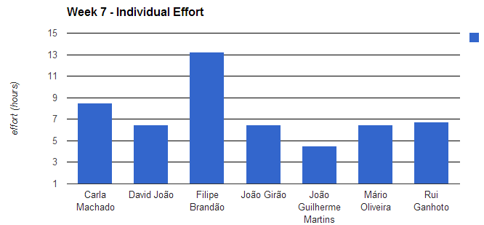

Figure 3: Week effort by team member

|  |  |
| --- | --- |
| **Name** | **Effort(hours)** |
| Carla Machado | 8.5 |
| David João | 6.5 |
| Filipe Brandão | 13.25 |
| João Girão | 6.5 |
| João Martins | 4.5 |
| Mário Oliveira | 6.5 |
| Rui Ganhoto | 6.75 |

Table 3: Log of individual effort

# Individual log

**Carla Machado - Tasks done:**

* Planning Poker – 3h
* Planning of the Software Development Plan (Gant) – 2.5h
* Finishing writing the quality Plan – 0.75h
* Document reviews – 0.5h
* KOM preparation – Quality plan presentation – 0.25h
* Weekly report – 1h

**David João - Tasks done:**

* Planning Poker – 3h
* Writing of the meeting minute – 1.5h
* Writing of the Project Assessment and Control – 2h

**Filipe Brandão - Tasks done:**

* Planning Poker – 3h
* Planning of the Software Development Plan (Gant) –7h
* Got Software Development Plan ready for review – 2h
* Prepared slideshow for KOM – 1h
* Weekly report – 0.25h

**João Girão - Tasks done:**

* Planning Poker – 3h
* Writing of the next meeting agenda – 0.75h
* Changes to the Vision and Scope Document – 0.25h
* Helping in the Planning of the Software Development Plan (Gant) – 1h
* Preparation of the Earned Value – 1h
* Preparation of the presentation of Vision and Scope for the KOM – 0.5h

**João Martins – Tasks done:**

* Checking of the Verification and Validation Process – 2.25h
* Several discussions – 1h
* Changes to the Verification and Validation Process – 0.75h
* Revision of meeting minute – 0.5h

**Mário Oliveira - Tasks done:**

* Planning Poker – 3h
* Writing of the Project Assessment and Control Process – 2.5h
* Revision of weekly Report – Week5 – 0.25h
* Revision of the Verification and Validation Process – 0.25h
* Repository update – 0.25h

**Rui Ganhoto - Tasks done:**

* Project Planning Process approval – 0.25h
* Planning Poker – 3h
* Writing of the Project Assessment and Control Process – 2.5h
* Approval of the Verification and Validation Process – 0.25h
* Next meeting agenda and last meeting minute approval – 0.25h
* Writing of the Coding Review document – 0.5h